The Hindu Important News Articles & Editorial For UPSC CSE
Saturday, 28 March, 2026

c

Edition : International Table of Contents
Page 01  Syllabus : GS II : International Relations / Prelims Exam | Finalising India-U.S. trade deal not far-off, but some gaps remain: U.S. official
Page 02  Syllabus : GS III : Environment / Prelims Exam | Tiger skins, bear bile, lizard oil: Punjab districts emerge as ‘wildlife crime hotspots’ despite scant forest cover
Page 02  Syllabus : Prelims Exam | New butterfly species recorded in Arunachal named after Zubeen
Page 05  Syllabus : GS II : International Relations / Prelims Exam | Amid war, India sends out invites for BRICS meetings
Page 08  Syllabus : GS II : Indian Polity & Social Justice / Prelims Exam | A shade of dark: Reassessment of framework governing rights of transgender persons is due
Page 08 : Editorial Analysis  Syllabus : GS II & III : International Relations and Indian Economy | India’s growth claims, a clash with data reality

Page 01 : GS II : International Relations / Prelims Exam
To understand the current "gaps," one must look at the preceding year. In mid-2025, trade relations soured as the U.S. imposed a peak effective tariff of 50% on Indian goods (a combination of a 25% "reciprocal" tariff and a 25% punitive duty linked to India’s purchase of Russian oil).
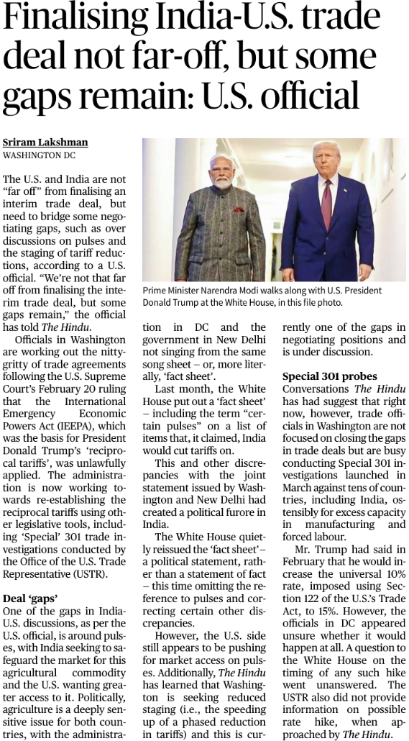
By early 2026, a framework was reached to reduce these tariffs to 18%, but a landmark U.S. Supreme Court ruling on February 20, 2026, invalidated the legal basis (IEEPA) for these reciprocal tariffs, forcing the U.S. administration to scramble for new legislative tools like Section 122 and Special 301 investigations.
Key "Gaps" in the Trade Deal
1. The "Pulses" Paradox (Agriculture)
Agriculture remains the most sensitive "red line" for both nations.
- India’s Position: India seeks to protect its domestic farmers and maintain high tariffs on pulses to ensure price stability and self-sufficiency.
- U.S. Demand: The U.S. is pushing for greater market access for its pulse exporters.
- The "Fact Sheet" Furore: A diplomatic spat occurred when the White House published a "fact sheet" claiming India had agreed to cut tariffs on "certain pulses." India’s strong pushback forced the U.S. to reissue the document, omitting the reference, highlighting the lack of consensus.
2. Staging of Tariff Reductions
- The Issue: Washington is pushing for "reduced staging," which means they want India to accelerate the timeline for lowering its tariffs.
- India’s Strategy: New Delhi prefers a "phased reduction" to allow domestic industries—particularly MSMEs and the dairy/poultry sectors—time to adjust to increased competition.
3. Legislative Uncertainty (Special 301 & Section 122)
Following the SCOTUS ruling, the U.S. is using Section 122 of the Trade Act of 1974 to impose a temporary 10% surcharge (potentially rising to 15%).
- Special 301 Probes: Launched in March 2026, these investigations target India’s "excess manufacturing capacity" (specifically in solar modules and steel) and "forced labor."
- Impact: These probes act as "negotiating leverage" for the U.S., effectively keeping Indian officials on the defensive while the interim deal is finalized.
Strategic Significance
For India:
- Export Competitiveness: Reducing tariffs to 18% (or lower) is vital for labor-intensive sectors like textiles, leather, and gems, where India faces stiff competition from Vietnam (20%) and Bangladesh (20%).
- Strategic Autonomy: India’s commitment to reduce Russian oil imports in exchange for trade concessions shows a pragmatic shift, though it risks straining ties with Moscow.
For the U.S.:
- Countering China: Deepening trade with India is part of the "friend-shoring" strategy to build resilient supply chains outside of China’s orbit.
- "Reciprocity" Doctrine: The Trump administration’s focus on "reciprocity" signals that the U.S. no longer views India through a "preferential" lens (like the old GSP system) but as a peer competitor that must open its markets.
Conclusion
The India-U.S. trade relationship in 2026 is moving away from broad strategic rhetoric toward hard-nosed transactionalism. While the "interim deal" is close, the remaining gaps in agriculture and the U.S.'s shift toward investigative trade tools (Section 301) suggest that even a signed deal may be fragile. For India, the challenge lies in balancing the "Goldilocks" zone: gaining market access for its exports without compromising the livelihoods of its massive farming population or its digital sovereignty.

UPSC Prelims Exam Practice Question
Ques: Which of the following sectors are most vulnerable to tariff shocks in India-U.S. trade?
1. Textiles
2. Gems and Jewellery
3. Dairy
4. IT Services
Select the correct answer:
(a) 1, 2 and 3 only
(b) 1 and 4 only
(c) 2 and 3 only
(d) 1, 2, 3 and 4
Ans: a)
UPSC Mains Exam Practice Question
Ques: India-U.S. trade relations are increasingly shifting from strategic cooperation to transactional negotiation. Discuss in the context of recent tariff disputes. (150 Words)

Page 02 : GS III : Environment / Prelims Exam
Traditionally, wildlife crime is associated with biodiversity hotspots like the Western Ghats or the Northeast. however, a recent study published in the Journal of Threatened Taxa reveals that Punjab, despite having less than 3.6% forest cover, has emerged as a significant hub for illegal wildlife trade. This shift highlights how trafficking networks exploit human-dominated landscapes and transit corridors, moving away from the "jungle-centric" model of poaching.
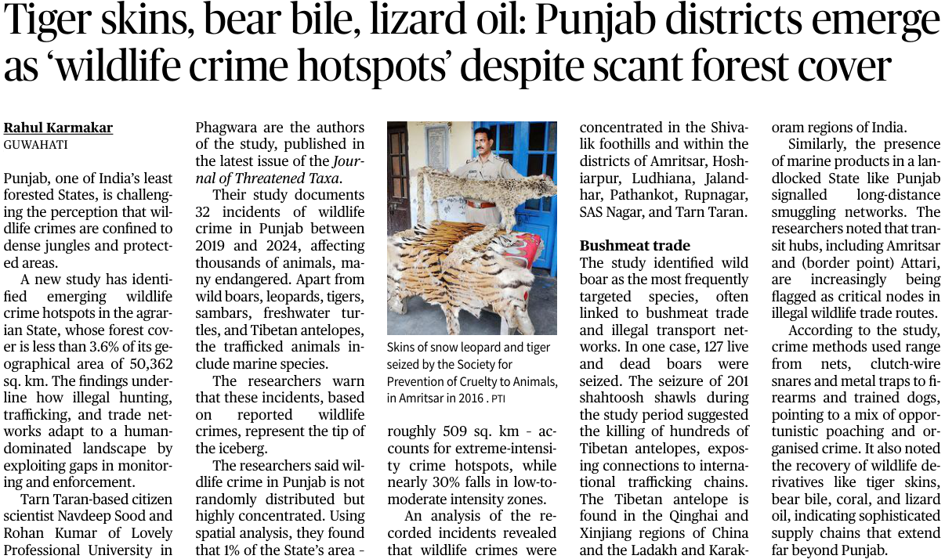
Key Findings: The "Hotspot" Paradox
1. Spatial Concentration
The study uses spatial analysis to show that wildlife crime is not random:
- High-Intensity Zones: Only 1% of Punjab’s area (approx. 509 sq. km) accounts for "extreme-intensity" crime.
- Geographic Focus: Crimes are concentrated in the Shivalik foothills and major urban/border districts including Amritsar, Ludhiana, Jalandhar, Pathankot, and SAS Nagar (Mohali).
2. The Species Spectrum
The diversity of seized items points to both local poaching and international smuggling:
- Local Macro-fauna: Wild boar (most frequent), leopards, sambars, and freshwater turtles.
- High-Value Derivatives: Tiger skins, bear bile, and lizard oil.
- International Links: The seizure of 201 Shahtoosh shawls (made from the underfur of the endangered Tibetan Antelope/Chiru) and marine products in a landlocked state indicates Punjab's role as a critical node in global trafficking chains.
3. Modus Operandi
The methods used reflect a mix of opportunistic and organized crime:
- Tools: Clutch-wire snares, metal traps, firearms, and even trained dogs.
- Nodes: Transit hubs like Amritsar and the Attari border are flagged as critical "leakage" points for smuggling into and out of India.
Issues and Implications
A. The Transit Hub Theory
Punjab’s emergence is likely due to its robust infrastructure and connectivity. As a border state with high-speed road networks and international airports, it serves as a "collection and forwarding" point for derivatives coming from the Himalayas (Leopards/Chiru) or Central India (Tigers) heading toward international markets.
B. Regulatory Gaps
- Low Forest Cover = Low Vigilance: Because Punjab is not perceived as a "wildlife-rich" state, enforcement resources (Forest Guards, specialized units) are likely thinner compared to states like Madhya Pradesh or Assam.
- The "Bushmeat" Economy: The high frequency of wild boar poaching indicates a thriving, unregulated local market for bushmeat, often overlooked by mainstream law enforcement.
C. Legal Frameworks Involved
- Wildlife (Protection) Act, 1972: Most species mentioned (Tiger, Leopard, Tibetan Antelope) fall under Schedule I, attracting the highest level of protection and penalties.
- CITES (Convention on International Trade in Endangered Species): The presence of Shahtoosh and marine products involves violations of international treaties which India is a signatory to.
Conclusion
The situation in Punjab serves as a "canary in the coal mine" for wildlife conservation in India. It proves that biodiversity density is not a prerequisite for wildlife crime. To combat this, India must shift from "habitat-based policing" to "intelligence-led enforcement" that monitors transit hubs and urban markets. Strengthening the Wildlife Crime Control Bureau (WCCB) presence in non-forested states and integrating citizen science (as seen in this study) are essential steps to closing the gap between poaching in the wild and consumption in the city.

UPSC Prelims Exam Practice Question
Ques: Which of the following best explains the “Transit Hub Theory” in wildlife crime?
(a) Wildlife crimes occur only near protected areas
(b) States with high biodiversity are major consumers of wildlife products
(c) Well-connected regions facilitate movement of illegal wildlife goods
(d) Wildlife trade is restricted to international borders only
Ans: (c)
UPSC Mains Exam Practice Question
Ques: Evaluate the effectiveness of India’s legal and institutional framework in tackling wildlife crime. Suggest improvements. (150 Words)

Page 02 : Prelims Exam
Arunachal Pradesh, often called the "Cradle of Speciation," has yielded a new addition to India’s entomological diversity. Researchers have identified a new butterfly species, Euthalia zubeengargi (common name: Basar Duke), in the Leparada district. The naming of the species after the late Assamese cultural icon Zubeen Garg underscores the deep-rooted connection between the people of the Northeast and their natural heritage.
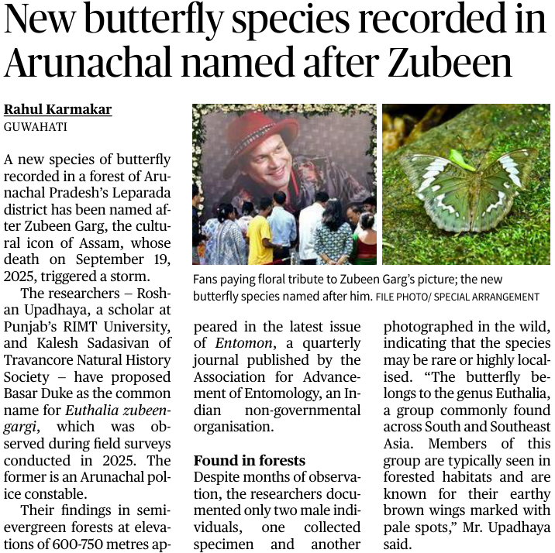
Key Scientific Details
1. Classification and Physical Traits
- Genus: Euthalia (Admirals and Dukes). This genus is widespread across South and Southeast Asia.
- Characteristics: Typical of its genus, it features earthy brown wings with distinct pale spots, providing camouflage within forest undergrowth.
- Habitat: Recorded in semi-evergreen forests at elevations between 600–750 meters.
2. Rarity and Distribution
- Location: Found specifically in the Basar region of Leparada district, Arunachal Pradesh.
- Conservation Status: The researchers observed only two male individuals during months of field surveys. This suggests the species is either rare, highly localized, or highly seasonal, making its habitat critical for its survival.
3. Collaborative Research
The discovery is a result of a unique collaboration between:
- Roshan Upadhaya: An Arunachal Police constable and researcher (showcasing the importance of "citizen science").
- Kalesh Sadasivan: From the Travancore Natural History Society, Kerala.
Significance
A. Biodiversity of the Eastern Himalayas
Arunachal Pradesh is part of the Indo-Burma Biodiversity Hotspot. New discoveries like Euthalia zubeengargi confirm that the region’s high-altitude and transition-zone forests remain under-explored and possess high levels of endemism (species found nowhere else).
B. The Role of Citizen Science
The involvement of a police constable in a major scientific discovery highlights the role of "Para-taxonomists" and local stakeholders in conservation.
C. Taxonomy as a Cultural Bridge
Naming species after regional icons (Taxonymy) helps in:
- Public Awareness: Creating emotional connects between the public and obscure species.
- Conservation Advocacy: Making a case for the protection of specific forest patches (like the Basar forests) by linking them to cultural pride.
Conclusion
The discovery of the Basar Duke is a reminder of the "taxonomic gap" in India’s Northeast. While the naming honors a cultural legacy, the scientific reality points toward a fragile, localized population that requires immediate habitat protection. As India strives to meet its Kunming-Montreal Global Biodiversity Framework targets, such discoveries necessitate a shift toward protecting non-protected forest areas that harbor rare and unidentified life forms.
UPSC Prelims Exam Practice Question
Ques: Which of the following best explains the “Transit Hub Theory” in wildlife crime?
(a) Wildlife crimes occur only near protected areas
(b) States with high biodiversity are major consumers of wildlife products
(c) Well-connected regions facilitate movement of illegal wildlife goods
(d) Wildlife trade is restricted to international borders only
Ans: c)

Page 05 : GS II : International Relations / Prelims Exam
India has officially commenced its 2026 BRICS Presidency by issuing invitations for the Foreign Ministers’ Meeting (May) and the 18th BRICS Summit (September). However, the "expanded BRICS" (BRICS+) face a trial by fire as internal divisions over the escalating West Asia war—specifically involving members like Iran and the UAE—threaten the grouping’s ability to issue a unified geopolitical statement.
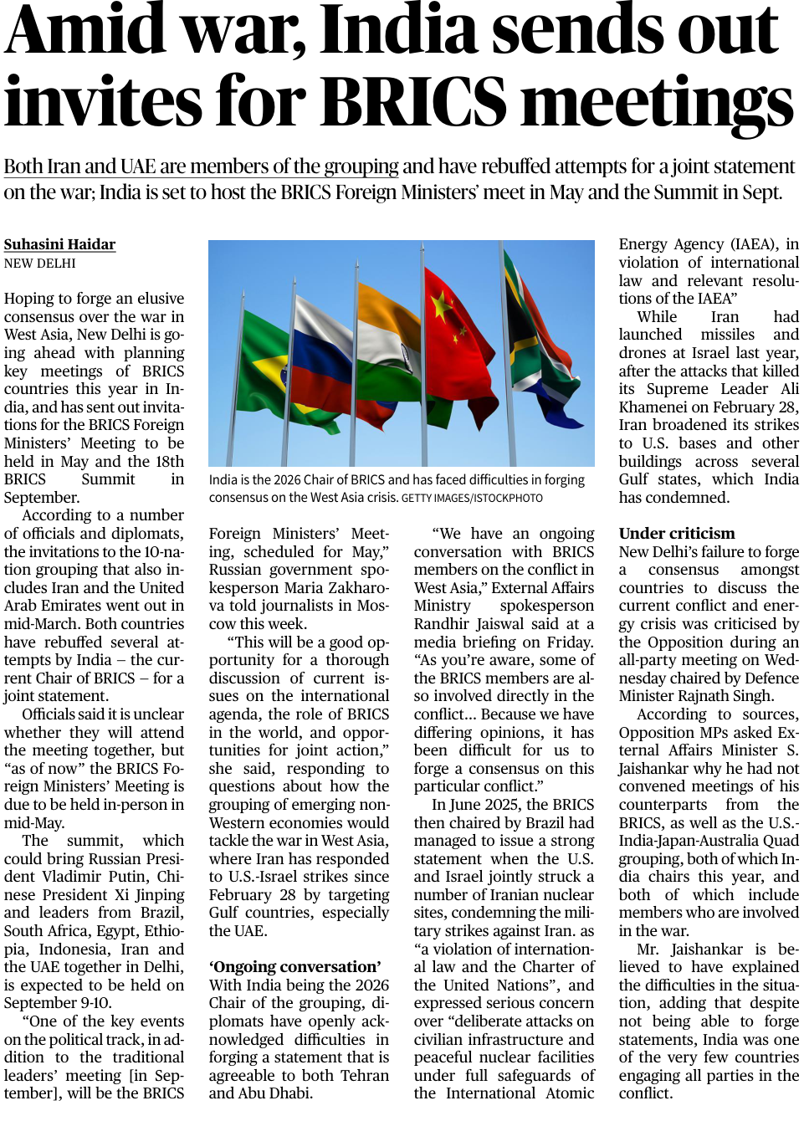
Key Conflict Dynamics in 2026
1. The West Asia Escalation
The current friction stems from a series of military actions:
- Initial Spark: Joint U.S.-Israel strikes on Iranian nuclear sites in 2025.
- The February 28 Incident: Following the killing of Iran’s Supreme Leader, Iran expanded its retaliatory strikes beyond Israel to include U.S. bases and infrastructure in Gulf states (specifically the UAE).
- The Deadlock: India, as Chair, is struggling to mediate between Iran (a direct combatant) and the UAE (a target of strikes), both of whom are now full BRICS members.
2. The Consensus Challenge
- The "Joint Statement" Hurdle: Unlike the June 2025 statement under Brazil's chairship (which condemned strikes on Iran), the current situation involves intra-BRICS friction. Both Iran and the UAE have rebuffed India’s attempts at a consensus document.
- The "Fact Sheet" vs. Diplomacy: India’s External Affairs Ministry has candidly admitted that "differing opinions" among members involved directly in the conflict make a common ground nearly impossible at this stage.
India’s Strategic Dilemma
A. Balancing "Strategic Autonomy"
India finds itself in a unique yet precarious position. It is one of the few global powers maintaining active diplomatic channels with:
- The West (via the Quad, which India also chairs in 2026).
- The Global South/Emerging Economies (via BRICS).
- Regional Rivals: Maintaining ties with both Tehran and Abu Dhabi/Riyadh.
B. The "Credibility Test" for BRICS+
The 2024 expansion of BRICS was intended to give the Global South a stronger voice. However, the current crisis reveals a structural weakness: the inclusion of regional rivals (Iran vs. UAE/Saudi Arabia) brings bilateral baggage into a multilateral forum, potentially paralyzing its decision-making.
C. Domestic Political Pressure
The Indian government faces internal scrutiny, with Opposition leaders questioning why the Quad and BRICS platforms haven't been utilized more aggressively to mitigate the energy crisis and the war. This highlights the link between international diplomacy and domestic economic stability (energy security).
Conclusion
India’s 2026 BRICS Chairship is no longer just about economic cooperation; it is a high-stakes exercise in crisis management. The success of the September Summit in New Delhi will depend not on "broad agreements," but on India’s ability to prevent the West Asia conflict from fracturing the grouping entirely. For New Delhi, the goal is to shift the focus from the battlefield back to the "multipolar" economic agenda, even if a joint political statement remains elusive.
UPSC Prelims Exam Practice Question
Ques: The term “BRICS+” refers to:
(a) Military alliance among BRICS nations
(b) Expansion of BRICS to include new member countries
(c) Trade agreement within BRICS nations only
(d) Financial assistance program by BRICS
Ans: b)
UPSC Mains Exam Practice Question
Ques: BRICS expansion has enhanced representation but weakened cohesion. Discuss in the context of recent geopolitical developments. (250 Words)

Page : 08 : GS II : Indian Polity & Social Justice / Prelims Exam
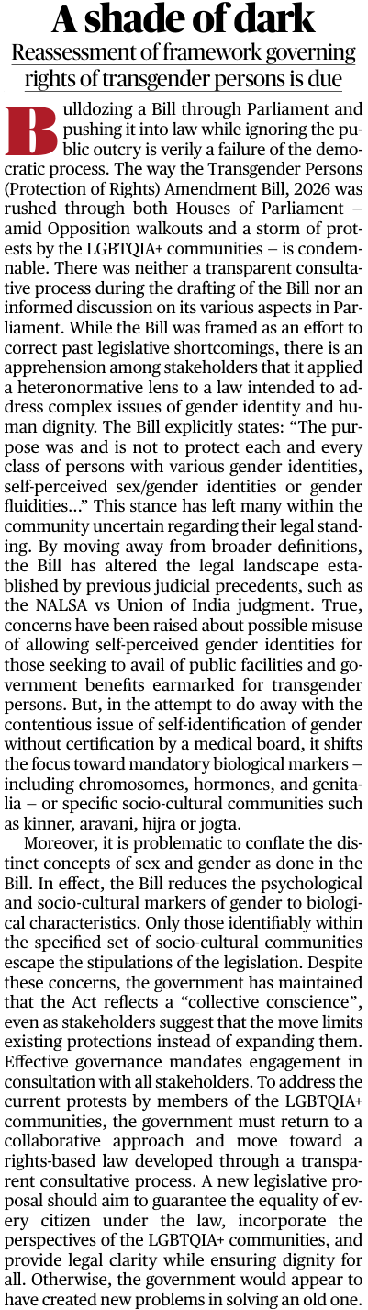
The passage of the Transgender Persons (Protection of Rights) Amendment Bill, 2026, has sparked a significant democratic and constitutional debate in India. While the government presents the Bill as a corrective measure to prevent the misuse of welfare benefits, the LGBTQIA+ community and civil society argue that it undermines the fundamental right to self-determination. The core of the controversy lies in the shift from a rights-based, self-identification model to a medicalized, biological model of gender.
Key Provisions and Contentious Issues
1. The Rejection of Self-Identification
- The Shift: The Bill moves away from the principle of self-perceived gender identity established by the Supreme Court in the NALSA vs. Union of India (2014) judgment.
- The New Requirement: It mandates certification by a medical board, focusing on biological markers such as chromosomes, hormones, and genitalia.
- Impact: This is seen as a violation of bodily autonomy and dignity, reducing a person's identity to clinical observations.
2. Narrowing the Legal Scope
- Specific Exclusion: The Bill explicitly states it is not intended to protect "each and every class" of gender fluid or self-perceived identities.
- Socio-Cultural Exception: Only specific traditional communities (e.g., Kinner, Aravani, Hijra, Jogta) escape some of the rigid biological stipulations.
- Result: This creates a legal vacuum for many queer and non-binary individuals who do not fit into these traditional categories.
3. Conflation of Sex and Gender
- Conceptual Error: The Bill treats "Sex" (biological) and "Gender" (social/psychological) as interchangeable.
- Heteronormative Lens: Critics argue the law is framed from a perspective that views gender only through binary or biological lenses, ignoring the psychological and social reality of the transgender experience.
Constitutional & Governance Perspectives
A. Violation of Judicial Precedents
The Bill appears to be in direct conflict with the NALSA Judgment, which declared that the right to choose one’s gender identity is essential to the Right to Life (Article 21) and Right to Equality (Article 14). By mandating medical exams, the Bill arguably re-introduces the "stigma of the clinic" that the judiciary sought to erase.
B. Legislative Process and "Democratic Failure"
- Lack of Consultation: The "rushing" of the Bill amid walkouts and without transparent public consultation is highlighted as a failure of the deliberative democracy model.
- The "Collective Conscience" Argument: The government’s defense—that the law reflects a collective conscience—is a subjective claim that may clash with the Constitutional Morality required in a diverse democracy.
C. The "Welfare vs. Rights" Dilemma
The government justifies the amendment as a way to prevent the misuse of government benefits. However, from a rights-based perspective, preventing potential fraud should not come at the cost of stripping an entire community of their fundamental right to identity and dignity.
Conclusion
The 2026 Amendment Bill represents a "shade of dark" for transgender rights in India because it prioritizes administrative convenience and biological essentialism over human dignity. Effective governance requires a rights-based approach rather than a restrictive one. To uphold the spirit of the Constitution, the government must re-engage with the LGBTQIA+ community and draft a framework that balances the prevention of fraud with the absolute protection of a citizen’s right to self-identify their gender. Without this, the law risks creating more marginalization than it seeks to solve.

UPSC Prelims Exam Practice Question
Ques: Which of the following Articles are most directly associated with transgender rights jurisprudence in India?
1. Article 14
2. Article 19
3. Article 21
4. Article 32
Select the correct answer:
(a) 1, 2 and 3 only
(b) 1 and 4 only
(c) 2 and 3 only
(d) 1, 2, 3 and 4
Ans: c)
UPSC Mains Exam Practice Question
Ques: The Transgender Persons (Protection of Rights) Amendment Bill, 2026 reflects a shift from a rights-based approach to a regulatory approach. Critically examine. (250 Words)

Page : 08 : Editorial Analysis

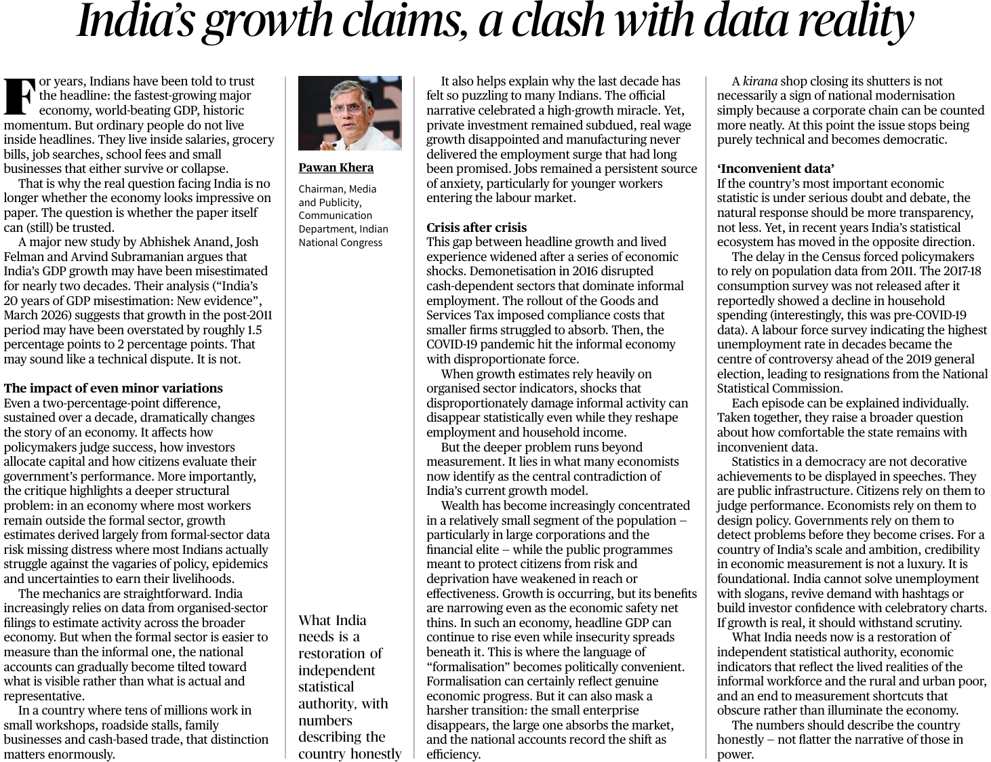
GS Paper II: International Relations and Indian Economy
UPSC Mains Exam Practice Question: Critically examine the challenges in measuring GDP in an economy dominated by the informal sector. (150 Words)

Context :
In March 2026, a significant debate has emerged regarding the credibility of India’s GDP estimation. The core of the argument—backed by a study by Abhishek Anand, Josh Felman, and Arvind Subramanian—is that India’s growth may have been overstated by 1.5 to 2 percentage points annually for nearly two decades. This critique suggests that while India appears as the "fastest-growing major economy" on paper, the underlying structural distress in the informal sector and a "statistical tilt" toward the organized sector have masked a different economic reality.
Key Arguments: The Data-Reality Gap
1. The "Formal Sector" Bias
- The Issue: India’s GDP calculation increasingly relies on data from organized-sector filings (MCA-21 database).
- The Flaw: In an economy where a vast majority of the workforce is in the informal sector (small workshops, kirana stores, cash-based trade), using formal-sector proxies to estimate informal activity is misleading.
- The Shift: When a small business closes and a large corporate chain takes its market share, the GDP shows "growth" due to better formal recording, even if total employment or welfare has decreased.
2. The Impact of Economic Shocks
The analysis highlights three major "shocks" that disproportionately hit the informal economy but may have been "statistically invisible" in headline GDP:
- Demonetisation (2016): Disrupted cash-dependent livelihoods.
- GST Rollout: Increased compliance costs that small firms struggled to absorb.
- COVID-19 Pandemic: Caused deep scarring in the unorganized workforce.
3. The "Inconvenient Data" Syndrome
The critique points to a weakening of India's statistical ecosystem:
- Census Delay: Continued reliance on 2011 population data for 2026 policy planning.
- Suppressed Surveys: Non-release of the 2017-18 Consumption Survey (which reportedly showed a decline in spending).
- Institutional Friction: Resignations from the National Statistical Commission (NSC) over disagreements regarding unemployment data.
Economic & Governance Perspectives
A. Measurement vs. Welfare
UPSC often asks about the "Jobless Growth" phenomenon. This critique provides a data-centric explanation: if GDP is growing at 7% but private investment is subdued and real wages are stagnant, the growth is likely concentrated at the top (K-shaped recovery). For a developing nation, GDP is a means to an end (poverty reduction), not the end itself.
B. Statistical Integrity
Reliable data is "public infrastructure." Inaccurate statistics lead to:
- Policy Errors: Raising interest rates or cutting subsidies based on "paper growth" while the ground reality is recessionary.
- Investor Distrust: Long-term foreign direct investment (FDI) depends on the transparency and predictability of economic indicators.
- Democratic Accountability: Citizens cannot effectively evaluate government performance if the "yardstick" (the data) is under doubt.
C. The Informal-Formal Transition
The government views "formalisation" as progress. However, if formalisation happens through the destruction of small enterprises rather than their graduation into the formal sector, it leads to wealth concentration and a thinning of the social safety net.
Conclusion
The debate over India’s GDP misestimation in 2026 is a call for statistical de-politicization. For India to achieve its "Viksit Bharat" (Developed India) goals, its economic measurements must reflect the struggles of the "invisible" informal worker as accurately as the profits of a Sensex company. Restoring the independence of the National Statistical Office (NSO) and conducting a fresh Census are not just technical requirements but democratic imperatives. As the analysis concludes: "The numbers should describe the country honestly—not flatter the narrative of those in power."

