The Hindu Important News Articles For UPSC CSE
Saturday :16 May, 2026

cc

Edition : International Table of Contents
Page 01  Syllabus : GS III : Indian Economy | India’s goods exports surge 14% in April to $43.6 billion: Centre
Page 04  Syllabus : GS II : International Relations | India, UAE sign pacts on energy, defence as Modi visits West Asian nation
Page 06  Syllabus : GS III : Indian Economy | ​  Trade, supply chains and economic statecraft
Page 06  Syllabus : GS II : International Relations | Superpower summit : As the U.S., China renegotiate ties, India must reinforce its strategic autonomy
Page 11  Syllabus : GS III : Indian Economy & International Relations | India-U.K. trade deal hits late-stage ‘sticking points’
Page 06 : Editorial Analysis  Syllabus : GS III : Indian Economy | Productivity, not just growth, for Viksit Bharat

Page 01 : GS III : Indian Economy
Despite persistent global macroeconomic headwinds, escalating geopolitical tensions in West Asia, and supply chain disruptions, India’s external sector has demonstrated remarkable resilience. Official data released for April 2026 highlights a significant milestone: merchandise exports surged by 14% to $43.6 billion. Concurrently, a robust performance in services and a contraction in strategic imports have culminated in a dramatic 30% reduction in the overall trade deficit, bringing it down to $7.8 billion. This analysis delves into the core drivers, geographic shifts, and macroeconomic implications of this trade performance.
Key Highlights of the Trade Data (April 2026)
The performance of India’s trade basket can be bifurcated into merchandise and services components:
Trade Component | April 2026 Performance | Context / Comparison
Merchandise Exports | $43.6 billion | 14% year-on-year (YoY) growth
Services Exports | $37.2 billion | 13.4% YoY growth
West Asia Exports | $4.16 billion | Declined by 28% (vs. $5.78B in April 2025)
West Asia Imports | $10.5 billion | Declined by 31.6% (vs. $15.3B in April 2025)
Overall Trade Deficit | $7.8 billion | Contracted by 30% (Merchandise + Services)
Core Drivers of the Export Surge
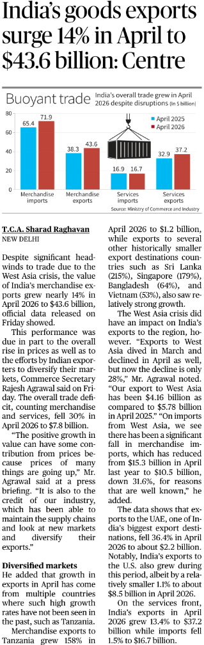
According to the Ministry of Commerce and Industry, the double-digit growth in goods exports can be attributed to two primary structural and cyclical factors:
- Global Commodity Price Inflation: A portion of the value growth is driven by the rising global prices of commodities. Higher unit-value realization has inflated the total dollar value of exports.
- Market Diversification Strategy: Indian exporters have successfully bypassed traditional stagnant markets to tap into non-traditional, emerging economies, creating a cushion against regional geopolitical shocks.
- Supply Chain Resilience: Despite maritime challenges in the Red Sea and broader West Asian conflict zones, Indian logistics and industries successfully maintained the continuity of outbound supply chains.
The Shift in Trade Geography: De-risking and Diversification
The April 2026 data reflects a profound structural shift in India's export destinations. Facing contractions in conventional hubs, India has expanded its footprint in Africa and South/Southeast Asia.
A. The Gainers (Emerging Markets)
- Tanzania: Emerged as a surprise frontline partner, with exports skyrocketing by 158% to $1.2 billion.
- Sri Lanka & Bangladesh: Neighborhood First policy dividends are visible, with exports growing by 215% and 64% respectively, indicating economic recovery and stronger bilateral integration in South Asia.
- Singapore & Vietnam: Driven by India's Act East policy and integration into ASEAN electronics/engineering supply chains, exports rose by 179% (Singapore) and 53% (Vietnam).
- United States: Maintained its position as a stable anchor, registering a modest growth of 1.1% to reach $8.5 billion.
B. The Decliners (The West Asia Factor)
The ongoing West Asia crisis has directly impacted trade with traditional powerhouse partners:
- Exports to the region fell to $4.16 billion (a 28% drop).
- Exports to the UAE (one of India's top three trading partners) witnessed a sharp contraction of 36.4%, dropping to $2.2 billion.
- Conversely, imports from West Asia dropped by 31.6% to $10.5 billion, heavily softening the blow to India's overall trade balance.
Macroeconomic Implications for India
Positive Structural Indicators:
- Contraction of the Trade Deficit: A 30% drop in the overall deficit relieves pressure on India’s Current Account Deficit (CAD), stabilizing the external sector and strengthening the Indian Rupee (INR) against global volatility.
- Services Sector as a Cushion: Services exports ($37.2 billion) are nearly neck-and-neck with merchandise exports. This sustained surplus in invisibles acts as a vital macroeconomic shock-absorber.
Challenges and Vulnerabilities:
- Price-Driven vs. Volume-Driven Growth: If growth is primarily fueled by rising global prices rather than real volume expansion, it poses a sustainability risk when global commodity cycles cool down.
- Geopolitical Vulnerability: The steep decline in trade with West Asia highlights India’s exposure to maritime choke points (like the Bab-el-Mandeb strait) and regional instability.
Conclusion and Way Forward
The trade data for April 2026 is an indicator of the changing dynamics of global trade, where adaptability is paramount. India’s ability to post a 14% export growth amid a severe West Asian crisis proves that its policy of market diversification is yielding tangible results.
Moving forward, for India to sustain this momentum and achieve its long-term target of $2 trillion in total exports by 2030, the government and industry must transition from price-led growth to volume-led growth. This requires fast-tracking free trade agreements (FTAs) with emerging regions, reducing domestic logistics costs via the National Logistics Policy, and scaling up high-value manufacturing through Production Linked Incentive (PLI) schemes to further insulate the economy from localized geopolitical shocks.
UPSC Mains Exam Practice Question
Ques: “India’s external sector resilience in 2026 reflects both strategic diversification and structural vulnerabilities.” Discuss in the context of recent trade data and geopolitical disruptions. (150 Words)

Page 04: GS II : International Relations
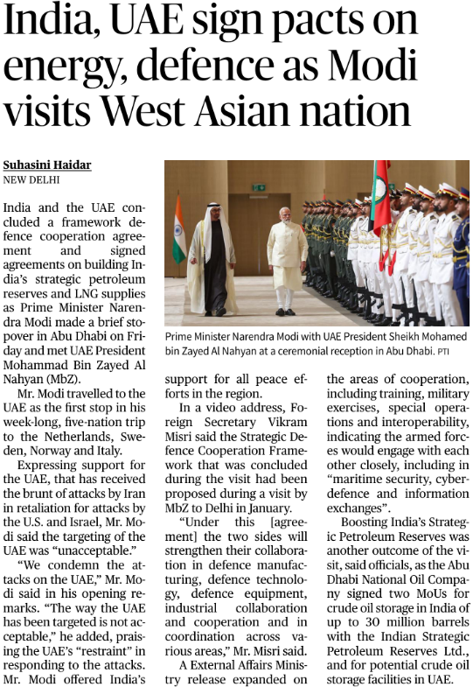
Against the backdrop of a highly volatile geopolitical climate in West Asia, Prime Minister Narendra Modi’s visit to Abu Dhabi marks a pivotal moment in India-UAE bilateral relations. By concluding a landmark Strategic Defence Cooperation Framework and locking in critical energy agreements on Strategic Petroleum Reserves (SPR) and Liquefied Natural Gas (LNG), the visit underscores a transition from a buyer-seller transactional relationship to a deeply integrated, institutionalized strategic partnership. Furthermore, India’s explicit diplomatic solidarity with the UAE amid regional conflict reflects New Delhi's growing willingness to take a clear stance on security in the Gulf.
Key Pillars of the 2026 Bilateral Agreements
The outcomes of the visit can be categorized into three pillars: Defence, Energy Security, and Geopolitical Diplomacy.
A. The Strategic Defence Cooperation Framework
Moving beyond routine joint military exercises, this framework institutionalizes long-term security architecture between the two nations:
- Joint Defence Manufacturing: Co-development and co-production of defence equipment, matching India’s Make in India push with the UAE's desire to build a domestic defence industry.
- Interoperability & Special Ops: Enhanced collaboration between the armed forces, focusing on high-end operational synergy, special operations, and training.
- Marsec and Cyberdefence: Deepening cooperation in maritime security (vital for the security of Indian Ocean sea lanes) and joint mechanisms to counter transnational cyber threats.
B. Energy Security: Beyond Crude Purchases
As global energy markets face supply chain volatility, India has fortified its energy buffer:
- Strategic Petroleum Reserves (SPR) Expansion: The Abu Dhabi National Oil Company (ADNOC) signed an MoU to store up to 30 million barrels of crude oil in India's underground rock caverns.
- Reciprocal Storage: Exploring potential crude oil storage facilities within the UAE for Indian access, creating an offshore energy cushion.
- LNG Commitments: Securing long-term LNG supply contracts to facilitate India's transition toward a gas-based economy.
C. Geopolitical Alignment & De-hyphenation
In a significant diplomatic move, PM Modi strongly condemned recent attacks on the UAE (linked to the ongoing U.S.-Israel-Iran escalation), calling them "unacceptable."
- This demonstrates India's active diplomatic posture in West Asia, stepping away from historical strategic ambiguity to explicitly safeguard the interests of its closest regional ally.
- Praising the UAE’s "restraint" positions India as a responsible global power advocating for regional de-escalation and maritime stability.
Comparative Matrix: Traditional vs. Contemporary India-UAE Ties
Dimension | The Past (Traditional Ties) | The Present (Strategic Realignment)
Energy | Simple buyer-seller arrangement (crude import). | Co-ownership of Strategic Petroleum Reserves (SPR) and LNG partnerships.
Defence | Limited to joint training exercises and port calls. | Defence technology co-development, cyberwarfare collaboration, and joint manufacturing.
Geopolitics | India maintaining a strictly passive, non-aligned stance in Gulf conflicts. | Active diplomatic solidarity and vocal condemnation of security threats to the UAE.
Macroeconomic and Strategic Implications
I. Energy Security and the SPR Architecture
India imports over 80% of its crude oil. The agreement to store 30 million barrels of ADNOC crude in Indian reserves significantly boosts India's energy insulation against sudden supply shocks or blockade of maritime chokepoints like the Strait of Hormuz.
II. Maritime Security in the Western Indian Ocean
The UAE’s location makes it a vital partner for India's SAGAR (Security and Growth for All in the Region) vision. Closer collaboration in maritime security helps counter piracy, secure critical Sea Lanes of Communication (SLOCs), and balance the expanding footprint of extra-regional powers (like China) in the western Indian Ocean and Arabian Sea.
III. The Diaspora and Remittance Anchor
The UAE houses over 3.5 million Indians, who contribute significantly to India's inward remittances. Ensuring the physical security and political stability of the UAE is directly linked to India's domestic economic well-being.
Potential Challenges in the Relationship
- The Middle East Geopolitical Tightrope: India enjoys strong strategic relations with Israel, Iran, and the Arab Gulf (Saudi Arabia/UAE) simultaneously. Deepening defence ties with the UAE and condemning attacks linked to Iran requires a delicate diplomatic balancing act to prevent friction with Tehran, which is vital for India's Chabahar port project.
- Execution Delays: Translating G2G (Government-to-Government) MoUs on defence manufacturing into commercial realities will require addressing bureaucratic hurdles and aligning standard operating procedures (SOPs) of both workforces.
Conclusion and Way Forward
Prime Minister Modi's brief stopover in Abu Dhabi yielded deep structural dividends, proving that the India-UAE relationship has matured into one of New Delhi’s most consequential bilateral equations. By intertwining its energy security with India's domestic storage infrastructure and linking its defence capabilities with Indian manufacturing, the UAE has signaled that it views India as a primary net security provider in the extended neighborhood.
Moving forward, India must fast-track the implementation of these defence and energy frameworks. Utilizing platforms like the I2U2 Grouping (India, Israel, UAE, USA) and the India-Middle East-Europe Economic Corridor (IMEC) will be essential to weave these bilateral achievements into a grander, multilateral framework for trans-regional connectivity and stability.
UPSC Mains Exam Practice Question
Ques: Would you like to explore how this evolving India-UAE dynamic impacts India's parallel strategic interests with Iran and the development of the Chabahar Port? (150 Words)

Page 06 : GS III : Indian Economy
The contemporary global order is witnessing a structural paradigm shift where the traditional boundaries between economics and geopolitics have completely collapsed. In this essay, Dr. Shashi Tharoor analyzes how supply chains, energy corridors, and technology ecosystems have emerged as the primary battlegrounds of global power—a concept known as Geo-economics.
For India, this shift represents a historic juncture. As global corporations look to de-risk from concentrated production hubs (the "China+1" strategy), India’s scale, domestic reforms, and strategic autonomy have positioned it to transition from a mere participant in globalization to an indispensable anchor of the new global economic architecture.
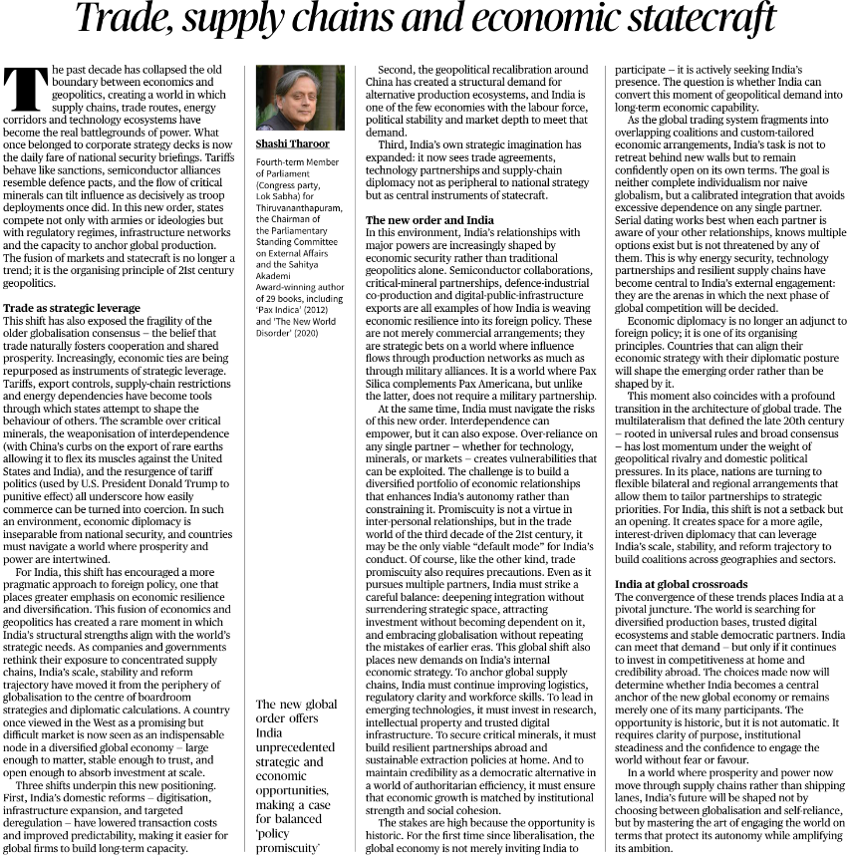
Core Themes and Concepts Handled
A. The Weaponization of Interdependence
The old globalization consensus posited that free trade inherently fosters global peace and cooperation. Instead, economic interconnectedness is now being repurposed as an instrument of strategic coercion.
- Examples: China’s export restrictions on rare earth elements to pressure the US and India; the aggressive use of punitive tariffs and sanctions as geopolitical tools.
- The Paradigm Shift: National security briefings now mirror corporate boardroom strategies, treating semiconductor alliances like defense pacts and critical mineral access like troop deployments.
B. "Pax Silica" vs. "Pax Americana"
Tharoor introduces a crucial conceptual distinction for foreign policy analysis:
- Pax Americana represents the post-WWII order guaranteed by US military alliances and security umbrellas.
- Pax Silica represents the emerging global order driven by technology, semiconductor supply chains, and digital networks. Crucially, thriving in Pax Silica requires robust technological collaboration and trust, rather than formal, binding military alliances.
The Triad Driving India’s New Strategic Positioning
The article outlines three internal and external structural shifts that have pushed India to the center of global boardrooms:
- India’s strategic reset in trade is being driven by a convergence of domestic reforms, geopolitical shifts, and a broader strategic vision of economic engagement. On the domestic front, the government has focused on digitization, infrastructure expansion, logistics modernization, and targeted deregulation to reduce transaction costs and improve ease of doing business.
- Simultaneously, changing global geopolitics—particularly the China+1 strategy—has created new opportunities for India as multinational firms seek stable, democratic, and large-scale production ecosystems.
- Alongside these developments, India’s policy imagination has expanded beyond conventional trade, viewing free trade agreements, supply-chain integration, and technology partnerships as central instruments of statecraft and strategic influence in an increasingly multipolar world.
"Strategic Trade Promiscuity": Navigating the Fragile Order
To survive in a fragmented global economy, Tharoor argues that India must adopt a policy of calibrated integration or "strategic trade promiscuity."
What does this mean for India's Foreign Policy?
- De-risking over Decoupling: India should avoid isolating itself behind protectionist walls, but must simultaneously prevent over-reliance on any single trading partner for critical imports (e.g., Active Pharmaceutical Ingredients, electronic components, or rare earths).
- Multi-Alignment (Serial Dating Concept): India must confidently pursue flexible, overlapping bilateral and regional partnerships (e.g., India-UAE CEPA, India-Australia ECTA, EU Trade and Technology Council) rather than waiting for stalling multilateral frameworks like the WTO. Each partner is aware of India's other choices, creating a balance where no single nation holds ultimate leverage over New Delhi.
Key Policy Prescriptions for India
To translate this geopolitical demand into long-term domestic capability, India must execute a targeted internal and external strategy:
Internal Dimensions
- Logistics & Infrastructure: Accelerate programs like PM GatiShakti and the National Logistics Policy to reduce the cost of doing business.
- Workforce Upskilling: Transform India’s demographic dividend into a highly skilled workforce capable of handling advanced manufacturing (semiconductors, green energy technology).
- Institutional Strength: Maintain regulatory clarity, protect intellectual property (IP), and ensure social cohesion to remain a credible, stable alternative to authoritarian efficiency.
External Dimensions
- Critical Mineral Diplomacy: Deepen engagements via the Mineral Security Partnership (MSP) and secure long-term asset acquisitions in Africa and South America.
- Digital Public Infrastructure (DPI) Exports: Leverage India's robust tech stack (UPI, Aadhaar, ONDC) as a tool of soft power and economic diplomacy across the Global South.
Conclusion
The defining challenge for 21st-century India does not lie in choosing between hyper-globalization and isolated self-reliance (Atmanirbhar Bharat). Instead, as Dr. Tharoor eloquently summarizes, it lies in mastering the art of engaging the world on terms that protect India's strategic autonomy while amplifying its global ambitions.
The transition from a rule-follower to a rule-shaper in the global trade arena is not automatic. It requires India to back its geopolitical weight with domestic economic competitiveness, ensuring that economic statecraft becomes the core engine driving its rise to a global superpower.
UPSC Mains Exam Practice Question
Ques: “The age of geopolitics is increasingly becoming the age of geo-economics.” Examine this statement in the context of contemporary global trade and technology rivalries. (150 Words)

Page : 06 : GS II : International Relations
The recent summit in Beijing between U.S. President Donald Trump and Chinese President Xi Jinping marks a critical juncture in contemporary international relations. Characterized by a "temporary truce" rather than a definitive resolution of deep-seated structural issues, the meeting highlights an attempt to inject predictability into an otherwise volatile relationship.
For India, this superpower détente is not merely a spectator sport. As the world's two largest economies negotiate a "constructive relationship of strategic stability," New Delhi faces the dual challenge of deflecting U.S. pressure while managing an increasingly assertive and confident China on its doorstep.
Key Takeaways from the Beijing Summit
The outcomes of the summit reflect a highly transactional approach aimed at crisis management rather than structural realignment:
A. The Economic "Truce"
- The "Three Bs" for the U.S.: President Trump secured commitments from Beijing to purchase 200 Boeing aircraft, increase imports of Beef, and scale up purchases of Boybeans.
- Concessions on Tech & Resources: The U.S. permitted 10 Chinese firms to resume buying advanced Nvidia chips. In return, China agreed to relax export controls on crucial rare earth elements (vital for global electronics and defense manufacturing).
- Institutional Frameworks: Both nations discussed establishing a Board of Trade (to handle tariffs and commercial disputes) and a Board of Investment (to clear Chinese capital injections into non-sensitive U.S. sectors).
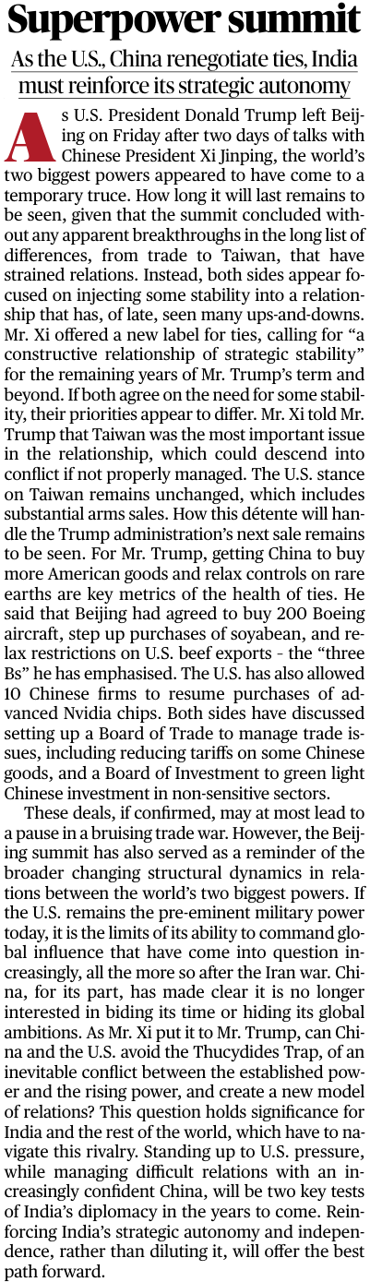
B. Core Structural Divergences
Despite the commercial deals, the fundamental geopolitical friction points remain unaddressed:
- Taiwan: President Xi designated Taiwan as the single most critical red line that could descend into hot conflict if mismanaged. Conversely, the U.S. signaled zero intention of altering its policy, maintaining its framework of substantial arms sales to Taipei.
- The Thucydides Trap: President Xi explicitly invoked this historical construct, questioning whether an established superpower (the U.S.) and a rising superpower (China) can bypass inevitable conflict to build a new model of great-power relations.
The Changing Global Order: Shift in Power Dynamics
The editorial highlights a profound structural shift in global geopolitics:
- Limits of U.S. Hegemony: While the U.S. retains its status as the premier global military force, its ability to shape global consensus and project unilateral influence has faced severe limitations, particularly highlighted by the fallout of the recent Iran war.
- An Assertive China: Beijing has officially abandoned its historic foreign policy dictum of "hide your strength, bide your time" (originally prescribed by Deng Xiaoping). Under Xi Jinping, China is explicitly articulating and pursuing its global ambitions.
The Double Litmus Test for Indian Diplomacy
As the U.S. and China rewrite their terms of engagement, India cannot afford to lean completely toward either pole. Instead, the current geopolitical climate presents two key tests for India's external statecraft:
- Test 1: Resisting Western Pressure: Standing up to U.S. secondary sanctions, trade demands, and rigid tech alignments without diluting national economic sovereignty.
- Test 2: Managing an Assertive China: Balancing bilateral friction (such as unresolved border issues and China's growing Indian Ocean footprint) while engaging economically with an increasingly confident Beijing.
Why Strategic Autonomy is India’s Best Path Forward:
- Avoiding Zero-Sum Alliances: A formal military alliance with the West would drastically limit India's diplomatic flexibility, turn China into a permanent adversary along the Line of Actual Control (LAC), and compromise India's ties with traditional partners like Russia.
- Issue-Based Coalitions: India must champion a multi-aligned approach—collaborating with the West in the Quad for maritime security in the Indo-Pacific, while simultaneously engaging with China in platforms like BRICS and the SCO to reshape global governance on financial and development terms.
- Economic Realism: India must keep its economic options open. It should benefit from Western tech transfers (like the US-India iCET) while ensuring it does not prematurely sever vital industrial supply chains linked to China.
Conclusion
The Trump-Xi summit demonstrates that even the bitterest of rivals will seek transactional stability when the costs of escalation become too high. This temporary truce serves as a reminder that in 21st-century geopolitics, there are no permanent friends or permanent enemies, only permanent interests.
For India, the path to becoming a pole in a multipolar world lies in reinforcing its strategic autonomy. By strengthening its domestic manufacturing via the Atmanirbhar Bharat framework, modernizing its military, and remaining confidently open to global trade on its own terms, India can ensure it is not treated as a swing state or a pawn in the U.S.-China superpower rivalry, but as an independent global anchor.
UPSC Mains Exam Practice Question
Ques: Critically examine the significance of “multi-alignment” in India’s contemporary foreign policy. How does it differ from traditional non-alignment? (250 Words)

Page 11 : GS III : Indian Economy
The bilateral relationship between India and the United Kingdom has entered a pivotal phase with the negotiation of the Comprehensive Economic and Trade Agreement (CETA). Originally signed in July 2025 and targeted for implementation by May 2026, the deal promises unprecedented market integration, with the U.K. offering duty-free access to 99% of Indian lines and India liberalizing over 90% of its tariff lines. However, the path to implementation has hit a late-stage hurdle due to the U.K.’s domestic policy shifts. The introduction of the U.K. Steel Strategy 2026, designed to protect its sovereign manufacturing base, has created unexpected friction, delaying the final rollout and forcing both nations to seek "creative" trade solutions.
Core Issue: The Steel Sticking Point
The primary bottleneck revolves around the U.K. Government’s announcement of a new steel trade protection measure, set to take effect from July 1, 2026, immediately succeeding its expiring steel safeguard regime.
Key Features of the U.K. Steel Measure:
- Drastic Quota Cuts: The volume of steel that can be imported into the U.K. tariff-free will be slashed by approximately 60% compared to previous safeguard levels.
- Doubling of Tariffs: Once these restricted quarterly quotas are exhausted, any additional imports will face an out-of-quota tariff of 50% (up from the current 25%).
- The "Melt and Pour" Requirement: Strict rules of origin require tracing exactly where the raw steel was melted and poured, directly targeting global supply chains.
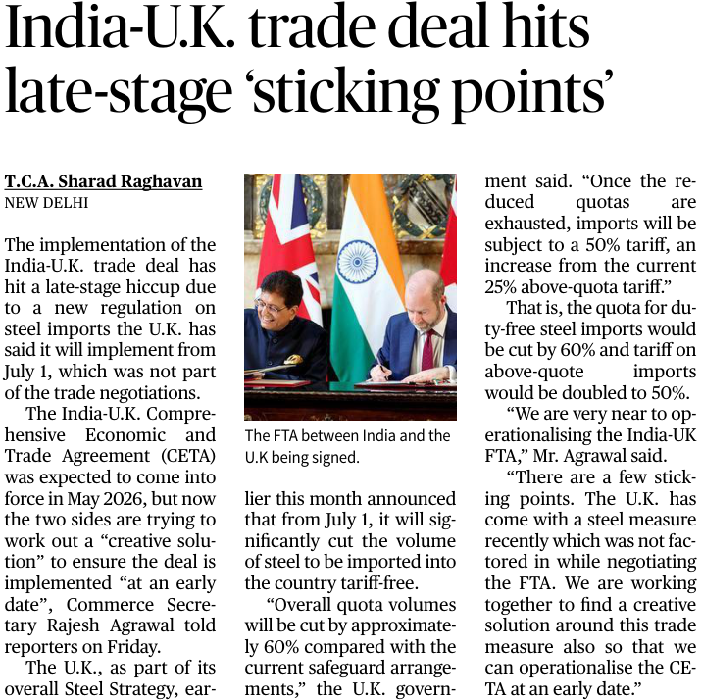
Why this matters for India: India is a major exporter of iron, steel, and downstream engineering goods to the British market. Out of India's total merchandise exports to the U.K., steel and related products constitute a highly lucrative component. The sudden imposition of a 50% tariff threatens the competitiveness of Indian steel majors like Tata Steel and JSW.
Dimensions of the India-U.K. FTA
To understand the broader implications, the CETA must be viewed through its macro-economic and strategic dimensions:
1. Market Access and Asymmetry
The treaty is highly ambitious. Under normal terms, it offers reciprocal benefits:
- Indian Gains: Duty-free access for labor-intensive sectors like textiles, leather, gems, jewelry, and machinery.
- U.K. Gains: Drastic reductions in India's historically high tariffs on British automobiles, Scotch whisky, and specialized machinery.
2. The Conflict of Domestic Priorities
The current standoff illustrates the tension between bilateral trade liberalization and national economic sovereignty:
- U.K.'s Perspective: Its domestic crude steel output has declined by over 50% in the last decade. Backed by an infrastructure push and national security requirements (e.g., the AUKUS submarine program), London views a robust, domestic green-steel industry as critical to national resilience.
- India's Perspective: India views the sudden introduction of unilateral safeguards as an erosion of the "zero-tariff" commitments negotiated during the FTA proceedings, effectively shifting the goalposts right before implementation.
Implications of the Delay
- The U.K.’s Steel Strategy announced on July 1, 2026—which includes a 60% quota cut and a 50% tariff on certain steel imports—has significant implications for India’s steel exports. These protectionist measures create trade asymmetry by restricting market access for Indian producers while broader trade negotiations continue.
- Consequently, the development may delay the operationalization of the India–U.K. Comprehensive Economic and Trade Agreement (CETA), generating uncertainty for businesses, investors, and supply chains that were anticipating smoother trade integration and greater market predictability.
- Economic Uncertainty: Industries on both sides that factored in a May 2026 rollout—such as automotive manufacturers expecting cheaper parts or retail lines adjusting inventory—now face prolonged compliance uncertainty.
- Precedent for Future FTAs: India is currently actively negotiating or reviewing trade pacts with major economies, including the U.S. (under Section 301 investigations) and South Korea. How India resolves this sticking point with the U.K. will set a benchmark for how it handles unilateral regulatory changes with other partner nations.
- Ratification Disparity: While the U.K. requires parliamentary scrutiny through both houses, India ratifies FTAs via the executive/cabinet route. The technical delay stalls the final execution of the "entry into force" agreement.
Way Forward: The "Creative Solutions"
To circumvent the deadlock without dismantling the CETA framework, trade negotiators are exploring alternative diplomatic and economic mechanisms:
- Country-Specific Quota (CSQ) Allocations: India could negotiate a protected, preferential share within the U.K.'s quarterly quota limits, ensuring that traditional Indian steel export volumes are insulated from the global 60% reduction.
- Grandfathering existing Contracts: Utilizing the transitional arrangements being explored by the U.K., where steel under contracts signed before mid-March 2026 is exempted from the 50% tariff for a specific buffer window.
- Proportionate Product Exclusion: Excluding specific specialized steel categories—such as those processed by Indian-owned entities like Tata Steel UK in Port Talbot—from the blanket tariff hikes.
Conclusion
The late-stage hiccup in the India-U.K. Comprehensive Economic and Trade Agreement underscores a fundamental reality of modern global trade: international treaties do not operate in a vacuum and are frequently vulnerable to shifting domestic industrial strategies. Despite the current impasse over steel quotas, the political and economic stakes are too high for either New Delhi or London to abandon the deal. By actively pursuing a "creative solution," both nations have demonstrated a mature approach to economic diplomacy. Resolving this issue swiftly will not only unlock billions in bilateral trade but will also solidify India’s position as a pragmatically adaptive, major global trading power capable of navigating complex protectionist headwinds.
UPSC Mains Exam Practice Question
Ques: The India-U.K. Comprehensive Economic and Trade Agreement (CETA) reflects both the opportunities and vulnerabilities of modern trade diplomacy. Discuss. (250 Words)

Page : 06 : Editorial Analysis

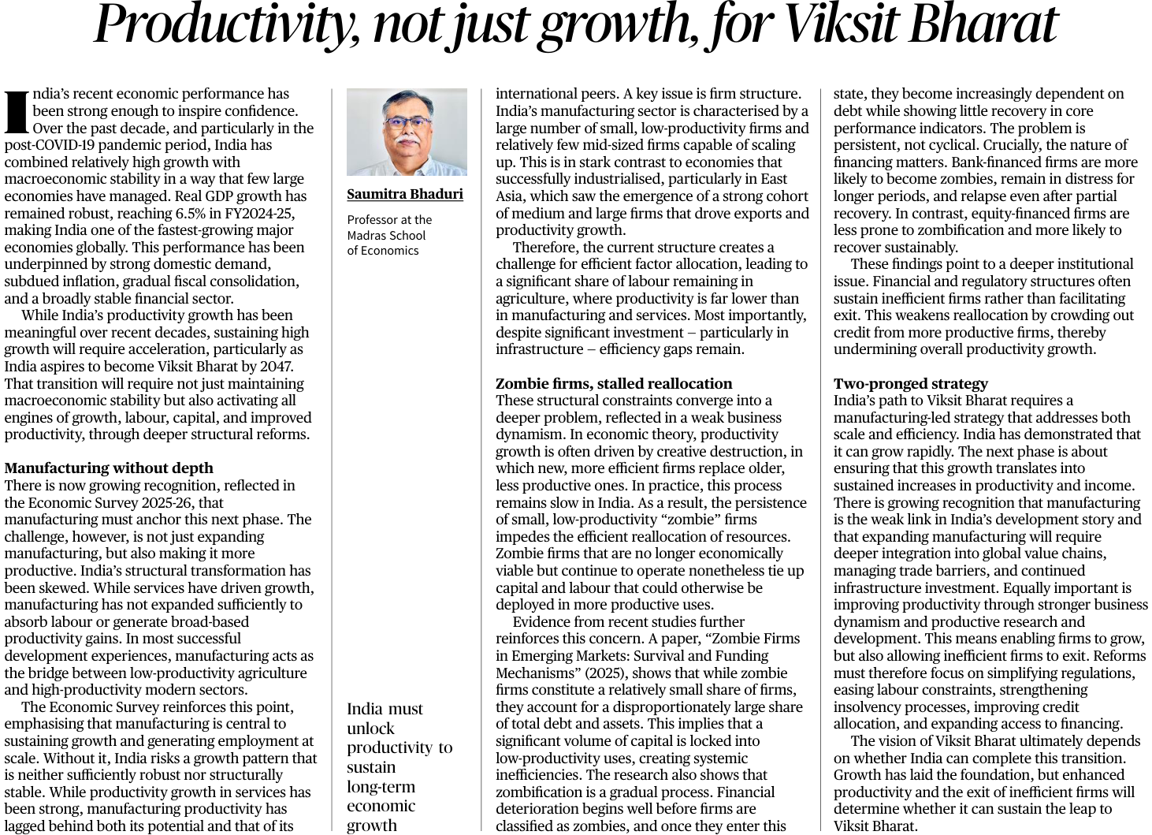
GS Paper III: Indian Economy
UPSC Mains Exam Practice Question: “India’s challenge is no longer merely achieving growth, but achieving productivity-led growth.” Discuss in the context of the vision of Viksit Bharat 2047. (250 Words)

Context :
India's recent macroeconomic trajectory paints a picture of resilient growth. Clocking a 6.5% Real GDP growth rate in FY2024-25, India stands out as a beacon of stability amidst global headwinds, characterized by subdued inflation and steady fiscal consolidation. However, achieving the vision of Viksit Bharat (Developed India) by 2047 requires transitioning from resource-driven growth to productivity-driven growth.
As highlighted by the Economic Survey 2025-26, relying solely on service-sector-led growth creates a structural imbalance. Sustaining long-term high growth rates demands a structural transformation where all economic factors—labor, capital, and total factor productivity—are optimized, particularly through a robust, scaled-up manufacturing sector.
Core Economic Challenges Highlighted
A. Manufacturing Without Depth and Structural Skewness
- The Missing Middle: India's manufacturing landscape is deeply fragmented. It is dominated by a "bipolar" distribution—a vast sea of micro and small, low-productivity enterprises alongside a few massive conglomerates, with a distinct absence of productive mid-sized firms.
- The East Asian Contrast: Unlike the successful industrialization models of East Asia (e.g., South Korea, Taiwan), where medium-sized firms scaled up rapidly to drive exports and absorb excess rural labor, India's manufacturing has failed to act as a transitional bridge.
- Labor Misallocation: Because manufacturing has not scaled up effectively, a disproportionately large share of the Indian workforce remains trapped in low-productivity agriculture, dragging down the aggregate productivity of the economy.
B. The Menace of "Zombie Firms" and Stalled Reallocation
A critical bottleneck to India’s business dynamism is the survival of Zombie Firms—economically unviable enterprises that continue to operate despite being structurally insolvent.
- Capital and Labor Hoarding: According to recent empirical evidence ("Zombie Firms in Emerging Markets: Survival and Funding Mechanisms", 2025), zombie firms block a disproportionately large share of total national debt and assets. This ties up precious capital that could otherwise flow to innovative, high-growth startups.
- The Banking Nexus: The research underscores a persistent institutional flaw—bank-financed firms are significantly more prone to zombification and long-term distress compared to equity-financed firms. Lax lending practices and delayed credit restructuring act as life-support systems for inefficient units.
- Stifling Creative Destruction: In a healthy capitalist economy, market forces drive "creative destruction" where inefficient firms exit to make way for efficient ones. In India, institutional and regulatory barriers prevent smooth exits, crowding out credit for productive firms.
Suggested Two-Pronged Strategy for Viksit Bharat
To convert growth into sustained, high-yielding productivity, India must execute a synchronized, two-pronged strategy:
- Achieving the vision of Viksit Bharat 2047 requires a dual strategy focused on expanding India’s global economic presence while improving domestic efficiency and competitiveness.
- The first pillar emphasizes scale and global depth through deeper integration into Global Value Chains (GVCs), greater investment in productive research and development, and the reduction of export and trade barriers to strengthen India’s manufacturing and export capabilities.
- The second pillar focuses on efficiency and dynamism within the domestic economy by strengthening the Insolvency and Bankruptcy Code (IBC), encouraging equity-based financing over excessive debt dependence, simplifying labor and regulatory frameworks, and enabling the exit of inefficient “zombie firms” so that capital and resources can move toward more productive sectors
Pillar 1: Driving Scale and Structural Depth
- Global Value Chain (GVC) Integration: India needs to move past protectionist tendencies, lower trade barriers, and deeply embed its manufacturing sector into global supply chains.
- Aggressive R&D Spends: Shifting focus from assembly-level manufacturing to high-value-added, IP-driven production by incentivizing corporate and public Research and Development.
- Infrastructure Utilization: Capitalizing on current massive public infrastructure investments (like PM GatiShakti) to drastically lower logistics costs, enabling small firms to scale.
Pillar 2: Enhancing Dynamism and Easing Market Exit
- Strengthening the Insolvency and Bankruptcy Code (IBC): Timely resolution and liquidation of distressed firms must be fast-tracked to prevent "zombification" and free up locked assets.
- Deepening Equity Markets: Shifting the corporate financing mix from heavy reliance on public sector banks toward equity, venture capital, and corporate bond markets, which enforce stricter market discipline.
- Regulatory and Labor Rationalization: De-clogging compliance machinery so that MSMEs do not face perverse incentives to stay small just to avoid bureaucratic scrutiny.
Conclusion
India’s current macroeconomic stability and 6.5% growth rate provide an excellent launchpad, but they represent the condition, not the guarantee, for becoming a developed nation. As the economic discourse pivots toward 2047, policy focus must shift from merely boosting headline GDP numbers to ruthlessly targeting Total Factor Productivity (TFP).
To bridge the gap between potential and reality, India must courageously embrace the market principle of allowing inefficient firms to fail while empowering productive firms to scale. Only by replacing structural stagnation with business dynamism can India successfully transition labor out of agriculture, deepen its manufacturing core, and secure a sustainable leap toward a truly Viksit Bharat.

